Learning Outcomes:
At the end of this section you should be able to …
Define Biology
Give examples of areas of study incorporated in Biology

Summery
Biology: is the study of living things
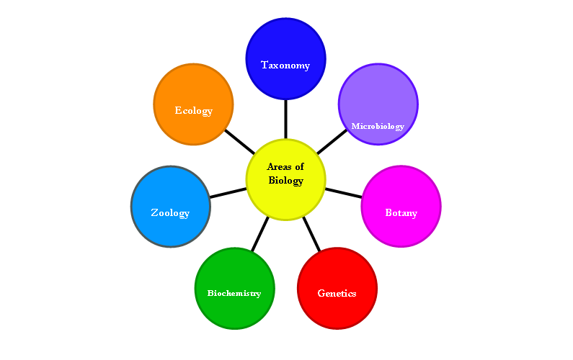
Areas of study

