At the end of this section you should be able to … | Y |  | N
Describe the structure of amoeba
Know an example of 1 amoeboid disease

Key words
Contractile vacuole, Pseudopods, Ectoplasm, Endoplasm,

Summary
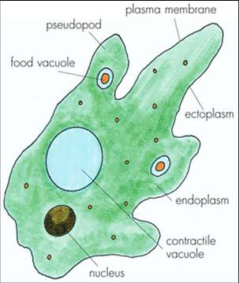
Diagram of amoeba

- Cell membrane
- Contractile vacuole
- Pseudopods
- Nucleus
- Ectoplasm
- Endoplasm
- Food vacuole
- Cytoplasm

Example of one amoeboid disease e.g. dysentery

