**Heart**

The heart is a muscular organ located in the ................................. ........................... . The heart pumps blood around the body in vessels called ..............................., .........................., and ..................................... Arteries branch into smaller vessels called ..................................... and veins branch into ................................... ..................................... ................................. takes place in the capillaries.

Blood flows under pressure in ................................ . Blood flow is ................................ in veins. Circulation of blood around the body is assisted by contraction of ............................... and the presence of ................................ in veins which prevents the ............................................... of blood.

There is a two –circuit circulatory system in humans.

The .......................... ............................ pumping blood to the lungs and the ....................... ...............................pumping blood from the heart to the remaining body tissue and back. Therefore the heart acts as a .............................. .........................

The heart has its own blood supply through the .............................. .......................... and the ........................................... ...............................................

........................................... blood flows from the body in the ...................... ......................... into the right atrium and then into the right ventricle, up through the ......................... ............................ to the lungs. ..................................... blood returns through the .......................... ............................ into the left atrium, from there into the left .............................. whose walls are very thick enabling blood to be pumped through the ........................ around the body.

**Control of heart beat**

Heartbeat is controlled by the .................................. situated in the right ...................... . The pacemaker is also known as the sino- atrial node.

The atria receive blood from the vena cava and ……………………. ……………………

The …………………………. sends waves of impulses through the walls of the atria. The atria contract and the bi- and tr-i cuspid valves ………….. . The ventricles are relaxed. This is known as the …………………… The impulses are then picked up by the ............................... ............................... node located in the ……………..between the atria and ventricles. The impulses pass from the a/v node down the septum and into the …………………………… which contract. This is known as the ………………………….. The bi- and tr-i cuspid valves close and the semi-lunar valves ………………. Blood is forced out of the ventricles through the ……………………….. artery and …………………

The first sound of the heart beat is caused by the closing of the ........................... and .......................... valves. The second sound is caused by the closing of the .............................. ........................ valves.

Arteries have a ........................ which can be felt as blood flows under pressure in an artery at the wrist. Blood pressure measures the amount of ........................ required to stop the flow of .............................through this artery.

**Systolic**

**B.P. =**

**Diastolic**

**Lymphatic system**

The lymphatic system is a one way system of vessels that returns excess .......................... .......................................to the blood circulatory system. The lymph ........................ assist in fighting infection in the body.

The hepatic portalsystem begins and ends in capillaries. It consists of a hepatic portal vein which connects the ................................... ..................................... to the .........................................

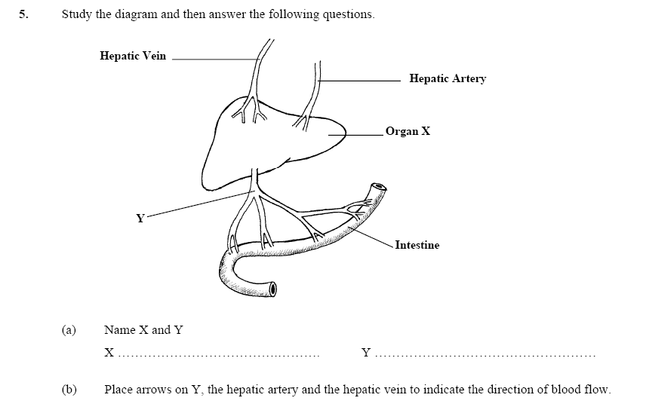

**(a)** Name blood vessel **A**. ________________________________________________________

**(b)** Is the blood in **A** oxygenated or deoxygenated? _____________________________________

**(c)** Name the chamber of the heart labelled **B**. _________________________________________

**(d)** Give **one** reason why the wall of chamber **B** is thicker than the wall of chamber **C**.

**____________________________________________________________________________**

(e) Copy the diagram label all parts and show direction of blood flow