ECOLOGY – A Study of an Ecosystem (Summary)

Learning Objectives

At the end of this section you should be able to:
 | Y | N
Give a broad overview of the selected ecosystem
Identify a number of habitats from the selected ecosystem.
Identify any five fauna and any five flora using simple keys.
Identify and use various apparatus required for collection methods in an ecological study.
Conduct a quantitative study of plants and animals of a sample area of the selected ecosystem. Transfer results to diagrams, graphs, histograms, or any relevant mode. Identify possible sources of error in such a study.
Investigate any 3 abiotic factors presented in the selected ecosystem. Relate results to choice of habitat selected by each organism identified in this study.
Note an adaptation feature by any organism in the selected ecosystem
From the information obtained in this study construct food chains, a food web, and a pyramid of numbers.
Prepare a brief report of the results obtained. .

Mandatory activity 1

- Identify any 5 fauna and any 5 flora using simple keys.
- Identify a variety of habitats within the selected ecosystem.
- Note an adaptation feature by any organism in the selected ecosystem.

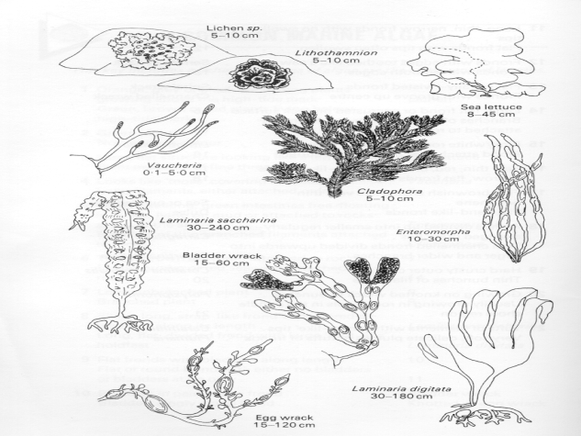  - Orange, grey or black encrusting plants growing above the high-tide mark  Green, brown or red plants living below high-tide mark | Lichen  2
- Green plant  Not green in colour | 3  6
- Large flat structure looking like a lettuce leaf  Plants made up of fine threads | Sea lettuce  4
- Looks like ‘moss’ covering the mud  Long filaments either attached or free | Vaucheria  5
- Looks like long green intestines free-floating in dykes, lying in mud or attached to rocks at top of shore  Bunches of thin branched filaments attached to rocks | Entermorpha  Cladophora

Organism name | Habitat | Adaptation

Mandatory activity 2
- Identify and use various apparatus required for collection methods in an ecological study

Method | Diagram | Used for collecting
Cryptozoic Trap |  | Small nocturnal animals e.g. slugs, woodlice
Pitfall trap |  | Small animals that walk along the surface of the ground e.g. beetles, spiders
Fish net |  | Small fish from a pond, rock pool or stream
Tullgren funnel |  | Small animals from leaf litter and soil samples e.g. worms, spiders
Pooter |  | Insects and spiders from the surface of leaves and leaf litter
Plankton net |  | Microscopic plants and animals from ponds, rock pools and streams
Sweep net |  | Insects from long grass and vegetation
Mammal trap |  | Small mammals e.g. mice , shrew

Mandatory activity 3

- Conduct a quantitative study of plants and animals of a sample area of a selected ecosystem.
- Transfer results to graphs, histograms, or any other relevant mode.
- Identify possible sources of error in such a study.

Procedure (% Frequency)
- I threw a quadrat randomly in the sample area of the selected ecosystem. I first threw a pencil over my shoulder and placed the quadrat where it landed.
- I recorded the presence or absence of the named plants and animals within each quadrat.
- I repeated for a number of throws
- I counted the total number of times the named organisms were present.
- I calculated the frequency.
- I recorded my results

Mandatory Activity 4
- Investigate any 3 abiotic factors present in the selected ecosystem, as listed.
- Relate results to choice of habitat selected by each organism identified in this study

 |  | Abiotic factors and measurements
Organism Name | Suitability of Habitat | Temperature (⁰C)  Apparatus used: | Humidity (%)  Apparatus used: | Light Intensity (Lux)  Apparatus used:
Limpet | Yes | 12 | 70 | 1005

Also

From the information obtained in this study construct food chains, a food web, and a pyramid of numbers.
Prepare a brief report of the results obtained.

- Food Chain

Seaweed Shrimp Sea anemone Gull

(iii) Pyramid of numbers

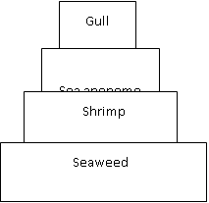
- Food Web
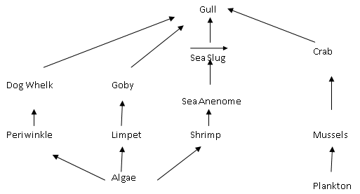
Sea anenome

