Fungi

Q 2016 3
The diagram shows asexual reproduction in yeast.
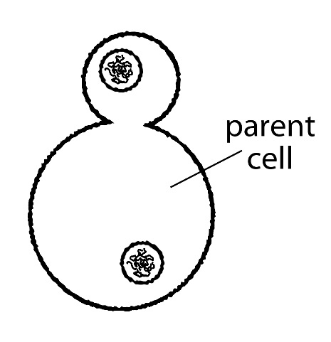

  - How do you know from the diagram that the reproduction is asexual?
  - What name is given to this type of asexual reproduction?
  - (i) How does the genetic make-up of the new yeast cell relate to that of the parent cell? (ii) Explain your answer.
  - Give an advantage and a disadvantage of asexual reproduction in organisms such as yeast.
  - Name another organism which belongs to the same kingdom as yeast.

MS 2016 3
- Only one parent (cell)
- Budding
- (i) Identical
(ii) Reproduce by Mitosis
- Advantage: Rapid or characteristics maintained or no variation
Disadvantage: Increased risk of disease or overcrowding or increased competition or no variation
- Rhizopus or (field) mushroom or named fungus or named fungal growth

Q 2015 8
- (i) Fungi may be classified into two groups on the basis of their nutrition. One of these groups is the parasitic fungi. What is the other group?
(ii) Draw a labelled diagram of a reproducing yeast cell.
- Answer the questions below in relation to the growth of leaf yeast in the laboratory.
    - What principal nutrient was added to the agar for the yeast?
    - How did you introduce the yeast into the Petri dishes?
    - What did the yeast look like when it had grown on the agar?
- (i) Describe how you carried out the investigation into the effect of IAA on plant tissue.
(ii) What were the results of your investigation?

MS 2015 8

(a) (i) *Saprophytic [accept *saprobic]
(ii) Diagram: cell + nucleus + attached bud with bud (or a nucleus) labelled
(b) (i) Malt (extract)
(ii) Attach leaves (or leaf pieces) to (inside of) lid. Replace lid (on dish) or (dish) upright for 24 hours or one aseptic technique described
(iii) Pink colonies or pink with ‘colonies’ described
(c) (i) Some exposed to IAA and some not exposed to IAA or tissue exposed to different concentrations of IAA. Leave for at least 2 days. Measure (or record) growth or compare growth
(ii) Description of how concentration (or IAA) changed growth (of tissue)

Q 2015 15 (c)
(i) Draw a large labelled diagram to show the structure of Rhizopus.
(ii) 1. What is the role of fungi such as Rhizopus in nature?
2. Why is this role vital?
(iii) Give one structural difference between Fungi and Plantae.
(iv) Name the method of asexual reproduction in Rhizopus.
(v) Describe in detail the process of sexual reproduction in Rhizopus

MS 2015 15 (c)
(i) Diagram: rhizoids + hypha + sporangiophore + sporangium
Labels: Rhizoids / hypha(e) or stolon / apophysis / sporangium / sporangiophore / columella / spores / mycelium
(ii) 1. Decomposer (or description of decomposition)
2. (To allow) recycling of nutrients (or minerals or elements)
(iii) (Fungi) have (cell wall of) chitin or (Plantae) have (cell wall of) cellulose or (Fungi) have no chloroplasts or (Plantae) have chloroplasts
(iv) Sporulation
(v) Different strains of or ‘+’ and ‘-’ (hyphae) which produce / progametangia / (formation of) gametangia (and suspensors) / fertilisation / zygospore / meiosis or germination (of zygospore)

Q 2014 4 (a) and (b)
- The living world may be divided into five kingdoms: Monera; Protista; Fungi; Plantae; Animalia.
In the case of each of the following pairs of kingdoms give any structural feature of members of the first-named kingdom not found in members of the second kingdom.
- Fungi and Animalia.
- Plantae and Fungi
- Animalia and Monera
- Protista and Animalia
(b) In each of the following cases, name an organism that fits the description.
  - A multicellular fungus.
  - A member of the Protista that catches and consumes smaller organism
  - A harmful member of the Monera.

MS 2014 4 (a) and (b)
- (i) Cell wall or hypha (or named hypha) or mycelium or named reproductive structure
(ii) Chloroplast or cellulose cell wall or named anatomical feature
(iii) Nucleus or mitochondrion or multicellular or eukaryotic or nervous system or digestive system or reproductive system or muscular system
(iv) (Can be) unicellular or (can have) chloroplast or pseudopodia or contractile vacuole or food vacuole
- (i) Rhizopus (or bread mould) or other named fungus
(ii) Amoeba
(iii) Any named (harmful) bacterium
or named (harmful) effect of a bacterium
[NB The word ‘bacterium’ is essential if effect given]

Q 2012 8 (a&b)
(a) (i) Are fungi prokaryotic or eukaryotic?
(ii) Name one structure in plant cells not found in fungi.
(b) (i) What is the purpose of using agar when growing fungi or bacteria in the laboratory?
(ii) Suggest one reason why leaf yeasts are more plentiful in July than in March.
(iii) Describe how you introduced the leaf yeasts into agar plates.
(iv) What was the precise purpose of a control in this investigation?
(v) How did you recognise the leaf yeasts when they appeared on the agar?
(vi) How did you safely dispose of the plates at the end of the investigation?
(vii) Using the axes below, draw a graph to show how the number of leaf yeasts varied following their introduction into the plate.

MS 2012 8 (a&b)

8. (a) (i) *Eukaryotic | 3
(ii) Chloroplast | 3
(b) (i) (Source of) nutrients or substrate (for growth) or medium or visibility | 3
(ii) More leaves or more suitable temperature or more reproduction | 3
(iii) Description of an aseptic technique in transfer (of leaf) or method of attachment of leaf to lid | 3
(iv) To show that the yeast came from the leaf (or did not come from agar) | 3
(v) Pink (colonies) | 3
(vi) (Immerse in) disinfectant or autoclave | 3
(vii) Lag | 3
Log + stationary or log + decline | 3

Q 2012 14 (c)
(i) Answer the following questions in relation to sexual reproduction in the mould Rhizopus.
- Sexual reproduction in Rhizopus is normally triggered by an adverse environmental stimulus. Suggest one such stimulus.
- Draw diagrams to show the main events of sexual reproduction in Rhizopus. In your diagrams label three structures other than the zygospore.
- Give two advantages to Rhizopus of zygospore formation.
- Answer the following questions in relation to asexual reproduction in yeast.
  - What term is used to describe the process of asexual reproduction in yeast?
  - What happens to the new cells formed in the process?
  - How does asexual reproduction in Rhizopus differ from that in yeast?

MS 2012 14 (c)

14. (c) | (i) | Dehydration or other named  Diagram  Labels:  + and - / progametangia / gametangia / hypha / zygote  Can survive drought (or named adverse condition) / dispersal | 3
 |  |  | 6, 3, 0
 |  |  | 3(2)
 |  |  | 2(3)
 | (ii) | 1. *Budding | 3
 |  | 2. Forms a colony or break away (from the mother cell) | 3
 |  | 3. (Rhizopus) produces spores | 3

Q 2011 15(c)

The diagram below shows part of the mycelium of the fungus Rhizopus.
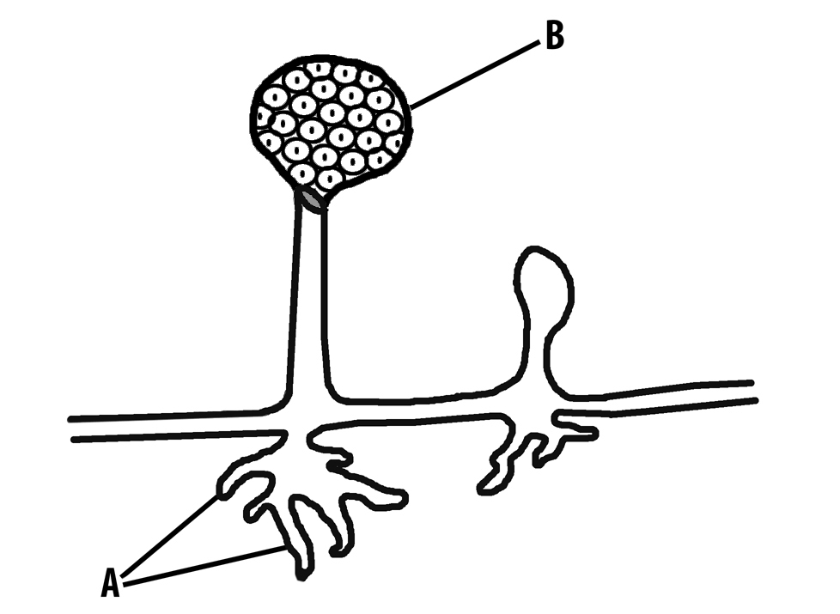
A

    - Give the name and state a function of the part labelled A.
    - Name part B and explain why the reproduction associated with it is asexual.
    - The nutrition of Rhizopus is described as being saprophytic.
- What does the term saprophytic mean?
- Explain the importance of saprophytic nutrition in the overall scheme of nature.
    - Saprophytic nutrition is a form of heterotrophic nutrition. What does the term heterotrophic mean?
    - Name another form of nutrition employed by some fungi.
    - Give two examples of harmful members of the kingdom Fungi

MS 2011 15(c)
15 | (c) | (i) | A = rhizoids | 3
 |  |  | Function = digestion or secretion or absorption or anchorage | 3
 |  | (ii) | B = sporangium | 3
 |  |  | (Reproduction is asexual because)
 |  |  | (the spores all develop from) one parent or no gametes involved | 3
 |  | (iii) | Feeding on dead matter  Breakdown of dead matter or breakdown of organic matter or  Recycling | 3
 |  |  |  | 3
 |  | (iv) | Obtains food from other organisms or does not make its own food | 3
 |  | (v) | Parasitic | 3
 |  | (vi) | Any two correct | 2(3)

Q 2010 6
  - (i) What is part A made of?
(ii)What is part B made of?
  - Briefly describe how viruses reproduce
(c) During 2009 swine flu spread through the population of many countries. Younger people were more at risk of becoming ill with swine flu than older people. Using your knowledge of the immune system, suggest a reason for this.
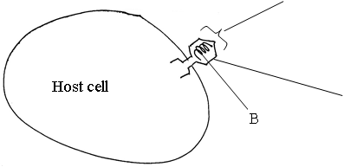

MS 2010 6

6. | (a) | A = protein;  B = Nucleic acid or DNA or RNA | 3  3
 | (b) | Attachment / (viral) nucleic acid into (host) cell / uses host structures (or described) / part(s) replicated / virus assembly / release (or lysis)  Any three | 3(3)
 | (c) | (Older people) previous exposure / antibodies (or active immunity or memory cells) | 3 + 2

Q 2009 14 (c)

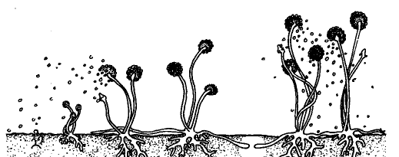
  - Identify the organism shown in the diagram.
C
A
B
X
  - To which kingdom does this organism belong?
  - Name the parts labelled A, B and C.
  - 1. Give a role, other than anchorage, for structure X.
2. Describe how X carries out this role.
  - Which term describes the mode of nutrition of this organism.
  - The cells of this organism are described as eukaryotic. Give two characteristic features of eukaryotic cells.
  - What corresponding term is used to describe bacterial cells?

MS 2009 14 (c)
14. | (c) | (i) | Rhizopus | 3
 |  | (ii) | Fungi | 3
 |  | (iii) | A = Sporangiophore | 2
 |  |  | B = Sporangium | 2
 |  |  | C = Spore | 2
 |  | (iv) | 1. Comment on nutritional role or spreading | 3
 |  |  | 2. Secretes enzymes or absorbs products or growth (on substrate) | 3
 |  |  | (Answers 1. and 2. must match)
 |  | (v) | Saprophytic | 3
 |  | (vi) | Nucleus | 3
 |  |  | Membrane-bound organelles or other named organelle | 3
 |  | (vii) | Prokaryotic | 3

Q 2007 8
(a) (i) Name a fungus, other than yeast, that you studied during your course.
(ii) Give one way in which the fungus that you have named in (i) differs from yeast.
(b) Answer the following questions in relation to your investigation of the growth of leaf yeast.
(i) It was necessary to use a nutrient medium. What is a nutrient medium?
(ii) Name the nutrient medium that you used.
(iii) The nutrient medium should be sterile. Explain the underlined term.
(iv) Describe, in words and/or labelled diagram(s), how you conducted the investigation.
(v) What was the result of your investigation?

MS 2007 8
(a) (i) Rhizopus or other 3
(ii) Multicellular or mode of respiration or size of structure 3
(b) (i) Material (or described) supplying food or material allowing growth
(ii) Malt agar 3
(iii) free of microorganisms 3
(iv) cut leaves/attach to lid/ how attached/ sealed dish/ invert/incubate any aseptic technique/ control described 4(3)
(v) pink colonies 3

Q 2005 9
(a) (i) Yeasts are eukaryotic organisms. What does this mean?
(ii) To which kingdom do yeasts belong?
- Answer the following questions in relation to an experiment that you carried out to investigate the growth of leaf yeast.
  - From which plant did you collect the leaf sample?
  - Describe how you collected the leaf sample.
  - What did you do with the leaves when you returned to the laboratory?
  - Nutrient agar plates are used in this experiment. What are nutrient agar plates and what is their purpose?
  - What did you observe in the agar plates at the end of the experiment?
  - Having finished the experiment, what did you do with the agar plates?

MS 2005 9

(a) (i) (Possesses) nucleus / membrane-bound organelles or named 3
(ii) Fungi 3
(b) (i) Name of plant 3
(ii) Cut or pick /container or avoidance of contamination / prevent leaves being crushed or shaken
Storage details / cutting procedure / attach to lid / method of attachment/avoidance of contamination any two 2(3)
(iii) Dishes (or agar) with additives (food or example) 3
To provide a medium or to allow growth 3
(v) Pink colonies (circles) or negative result qualified 3
(vi) Description of safe disposal 3

Q 2005 15 (b), (30, 30)

  - Saprophytic and parasitic fungi are widespread in nature.
    - Explain each of the underlined terms.
    - State a role of each of these types of fungus in the overall scheme of nature.
    - Give one example of a beneficial fungus and one example of a harmful fungus.
State a function for each of the following structures that are found in fungi; rhizoid, sporangium, gametangium, zygospore

Q 2005 15

- (i) non-cellular / one nucleic acid / can reproduce in host cell only
or obligate parasite / do not possess organelles or named organelle any two 2(3)
- Cold / ‘flu / polio / rabies / mumps / measles / AIDS (HIV) any two 2(3)
- B-cells/ T-cells or two named T cells e.g. helper / killer / suppressor / memory any two 2(3)
B-cells – produce antibodies/agglutination or lysis / memory
T-cells – recognise / destroy infected or damaged cells / memory / activation / suppress immune system
Helper T – stimulate B cells or stimulate killer T cells/ recognise antigens / Killer T – Destroy infected or damaged cells /
Suppressor T – Switch off immune system or explained / Memory T – memorise antigen any two 2(3)
- yes 3
in both cases the result is the production of antibodies 3

(b) (i) Diagram (wall, membrane) 3, 0
Labels 2(3)
- Cell wall / size / capsule / flagellum / plasmid 2(3)
- Produce spores 3
- Disease-causing 3
- Substances produced by micro-organisms / inhibit (growth or reproduction) of bacteria or fungi 2(3)
Misuse: survival of resistant strains / build up of resistant population 3
- (i) saprophytic – live on dead organisms (matter) 3
parasitic – living in or on another organism causing harm. 3
- saprophytes – recycling (of nutrients) / decay 3
parasites – keep populations under control / natural selection 3
- beneficial – yeast for brewing or baking / named edible fungus/ other 3
harmful – ringworm / athlete’s foot / potato blight / thrush /
dry rot / death cap / other 3
- Rhizoid – anchors / digestion / absorption 3
Sporangium – produces spores / stores spores / asexual reproduction 3
Gametangium – produces gametes / sexual reproduction 3

Q 2004 7
(a) Yeast cells produce ethanol (alcohol) in a process called fermentation. Is this process affected by temperature? Explain your answer
(b) Answer the following in relation to an experiment to prepare and show the presence of ethanol using yeast.
(i) Draw a labelled diagram of the apparatus that you used.
(ii) Name a substance that yeast can use to make ethanol.
(iii) What substance, other than ethanol, is produced during fermentation?
(iv) Describe the control that you used in this experiment.
(v) Explain the purpose of a control in a scientific experiment.
(vi)How did you know when the fermentation was finished?
(vii) Why were solutions of potassium iodide and sodium hypochlorite added to the reaction vessels after a certain period of time?
(viii) Name a substance produced during aerobic respiration that is not produced during fermentation.

Q 2004 7

(a) Yes 3
(Rate of) enzyme reaction (affected by temperature) 3
(b) Diagram 3, 0
[must include evidence of anaerobic conditions and two correct labels for 3 marks]
o Sugar or named sugar or starch 3
o Carbon dioxide or any product of glycolysis 3
o Yeast absent (or dead) in same set up 3
o Comparison or purpose described 3
o No more gas given off (no more bubbles) 3
o *NB - To test for alcohol – All candidates who attempt Q 3
o Water (allow other correct product from Kreb’s cycle) 3

Q 2004 15 (c)
    - Draw a labelled diagram to show the structure of Rhizopus. State one feature in your diagram that indicates that Rhizopus belongs to the kingdom Fungi.
    - Sexual reproduction in Rhizopus leads to the formation of a zygospore. Show, by means of labelled diagrams, the stages involved in the production of the zygospore.
    - Explain what happens when the zygospore reaches a location at which conditions for its germination are suitable.

MS 2004 15 (c)
      - Rhizopus diagram 6, 3, 0
3 labels 3(1)
Why a fungus: stolon or rhizoids or mycelium or hyphae or sporangium or spores
      - Diagram sexual reproduction: 6, 3, 0
(series of diagrams or 3 stages in one diagram)
3 labels 3(1)
      - Fate of zygospore: meiosis / hypha grows / sporangium (produces) / (asexual) spores / released / spores germinate any three 3(3)

