INVESIGATE THE EFFECT OF EXERCISE ON THE PULSE OF A HUMAN

Materials/Equipment

Timer
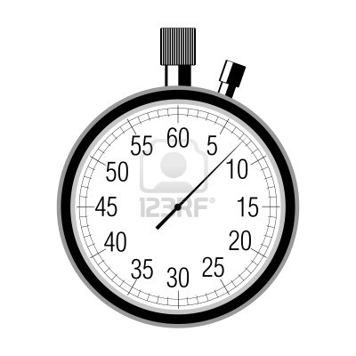
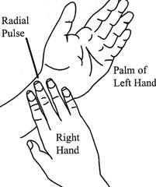

Procedure
- Sit down on a chair. Locate your pulse. Allow a few minutes to adjust.
- Count the number of pulses per minute and record.
- Repeat twice and calculate the average number of pulses per minute and record. This is called the resting heart rate.
- Walk gently for 2 minutes. Immediately measure your pulse rate and record.
- Run for 2 minutes. Immediately measure your pulse rate and record.
- Compare the pulse rates after the different exercises.
- Replicate the investigation or cross reference your results with other groups
- Draw a bar chart of your results.

Result
Before exercise | Trial 1 | Trial 2 | Trial 3 | Total | Average
Resting pulse rate (bpm)

After exercise | Gentle walking | Running
Pulse rate (bpm)

Conclusion/Comment

