At the end of this section you should be able to .......
3.3.1 Explain the Autotrophic nature of plants
3.3.1 Describe the uptake and process of transport of the following through the plant:
- Water: to include reference to root hairs, root cortex, xylem, osmosis, diffusion, root pressure, transpiration, and stomata
- Minerals: to include solubility in water, transport from the roots to all parts of the plant by the same route as water
- Carbon dioxide: directly from respiring cells or through stomata
- Photosynthetic products: production of carbohydrate and transport through phloem sieve tube cells
3.3.2 Modified plant food storage
Give one example of a root, stem and leaf modification as a food storage organ
H.3.3.7 Cohesion-Tension Model of Xylem Transport

Explain the work of Dixon and Joly : Cohesion-
The cohesion-tension model explains how water is transported in plants to extreme heights against the force of gravity.

Key Words
osmosis, diffusion, active transport, root pressure, cuticle, stomata, cohesion, adhesion, transpiration stream,

Nutrition in the flowering plant - Summary

Autotrophs: Plants are Autotrophs. They make their own food by a process called photosynthesis.

Photosynthesis
- Plants need light, chlorophyll, carbon dioxide and water to make food.
- Oxygen gas is released.

In order to carry out metabolism (e.g. photosynthesis, respiration), growth and reproduction, plants require 1. water, 2. carbon dioxide, and 3. minerals.

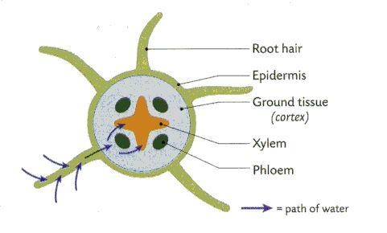
- Water
- Plants absorb water through their roots
- Roots contain numerous root hairs.
- Root hairs are found in the zone of differentiation
- Root hairs have thin walls not covered by a cuticle.
- The cell wall and cell membrane of young roots are permeable to water
- The large number of root hairs increase the surface area available for absorption.
- Absorption of water into the root hairs takes place by Osmosis

Osmosis is the diffusion of water from a region of higher water concentration to a region of lower water concentration across a selectively permeable membrane.

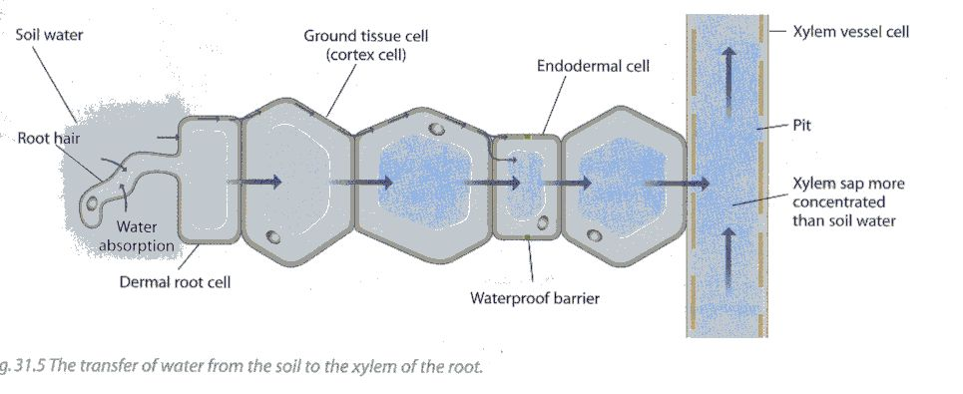
- Soil water is very dilute i.e. has a high water concentration
- Root hair cells have a low water concentration.
- Therefore water moves from the soil into the root hairs by osmosis
- Water diffuses from cell to cell across the ground tissue until it reaches the xylem.
- Xylem vessels now form the route for the transport of water to all parts of the plant.
- Xylem vessels form a continuous hollow pipeline from roots to leaves.

Movement of water in the xylem
The upward movement of water in the xylem is helped by a combination of Root pressure and Transpiration.

- Root Pressure
The transport of water up through the xylem is helped by root pressure. This pressure is created by water entering the root cells by osmosis which pushes the water up the xylem.

However this pressure while strong enough to push water as high as 20 m would not be strong enough to push water to the top of the tallest trees which can be over 100m tall.

- Transpiration
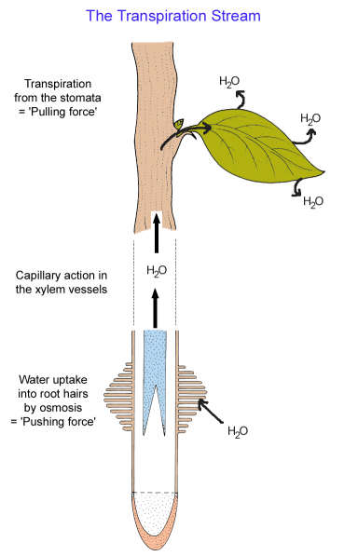
Transpiration is the evaporation of water from the surface of a plant. Most transpiration takes place through openings on the underside of the leaf - stomata

- When water evaporates from the cells in the leaf (transpiration), the cells become less turgid and more concentrated.
- This creates an osmotic gradient (change in concentration)
- This osmotic gradient causes the water to move from the xylem cells out to these cells in the leaf.
- This in turn causes water from the soil to flow into the root and enter the xylem at the centre of the root.
- Water lost from the top is replaced by water in the soil and this creates a stream of water to move upwards.
- This is known as the Transpiration stream

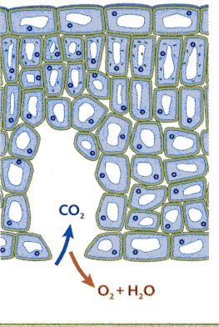
The loss of water from the leaves is controlled by cuticle and by stomata.
cuticle

Cuticle:
- A waxy covering on the dermal layer of leaves which reduces water loss (transpiration)

Stomata
- Openings on undersurface (lower dermal) of leaves
- Controlled by guard cells
- Normally closed at night - no photosynthesis
- Open by day – to allow exchange of gases
stomata
If water is in short supply the stomata can remain shut to conserve water.
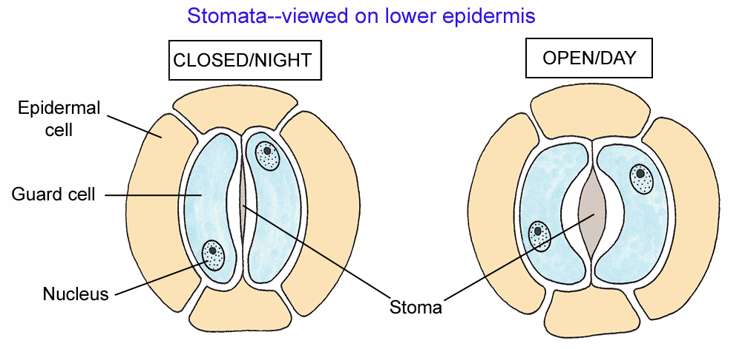

SOD: Stomata Open Day

2. Carbon Dioxide
There are two sources of carbon dioxide for photosynthesis
- Produced in the leaf cells by respiration.
- From the atmosphere through stomata.
- Carbon dioxide enters through the stomata
- It diffuses through the air spaces in the ground layer

3. Minerals
- Minerals required by the plant exist in the soil dissolved in water.
- They are transported from the roots to all parts of the plant by the same route as water.
- Only water enters by osmosis
- Minerals enter the root hairs by active transport i.e. energy is required to pump the minerals in.
Photosynthetic products:
The products of photosynthesis are oxygen gas and glucose
Oxygen gas – released through the stomata
Glucose can be either: 1. used as energy 2. converted to starch and stored in the leaves or 3. converted to sucrose and transported through phloem sieve tube cells to all parts of the plant for storage as starch or used in respiration

H.3.3.7 Cohesion-tension model
- The cohesion-tension model explains how water is transported in plants to extreme heights against the force of gravity.
- Theory first put forward by two Irish scientists Dixon and Joly working in TCD in 1895.

Cohesion: Is the attractive forces between the water molecules
Adhesion: Is the ability of different molecules to stick together

How the cohesion-tension model works
- Water evaporates from the xylem into the air spaces of the leaves and out through stomata (Transpiration)
- As transpiration pulls each water molecule out of the xylem, the next water molecule is pulled with it due to high cohesion.
- Water molecules also adhere (stick) to the walls of the xylem vessels.
- Provided there is a continuous column of water in the xylem tube, this pull is transmitted through the water right down the stem to the root.
- When water molecules are pulled in this way the entire column of water in the xylem is stretched and the water is said to be under tension.
- Transpiration causes this tension.
- The cohesive forces can hold water in a column without breaking when this tension is applied.
- This tension can pull a column of water in xylem tubes of very small diameter up to great heights

- During the day transpiration occurs and the stomata are open.
- The tension causes xylem to become narrower and so stems are slightly narrower by day.
- To prevent the xylem vessels collapsing inwards the xylem walls are strengthened with lignin.
- At night when transpiration stops the xylem become slightly wider.

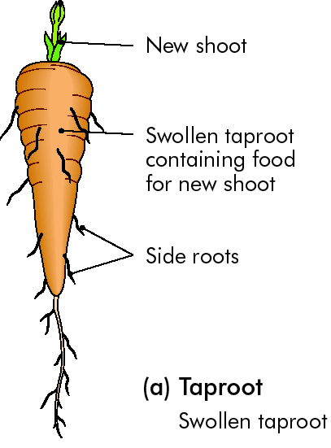
3.3.2 Modified plant storage organs Summary

(a) Root modification
In some plants e.g. dicots, the first root grows straight down to form the main root of the plant.
This root may become fleshy and modified to store food.
Example: carrot
Sugar is the food reserve.

(b) Stem modification
A tuber is a modified stem that functions in the storage of food e.g. potatoes

A Potato tuber is easily identified as a stem as it contains leaves and buds.
Starch is the food reserve

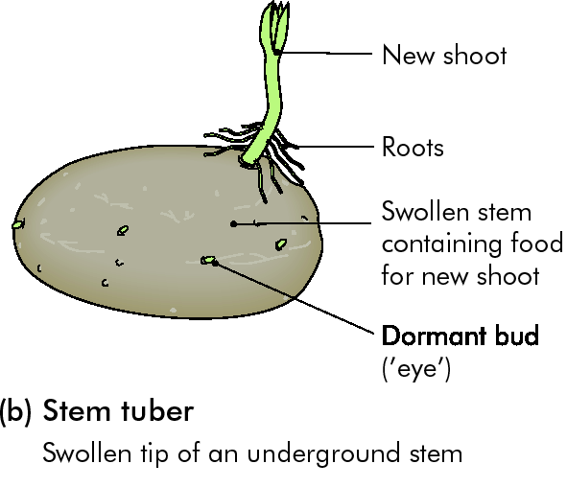

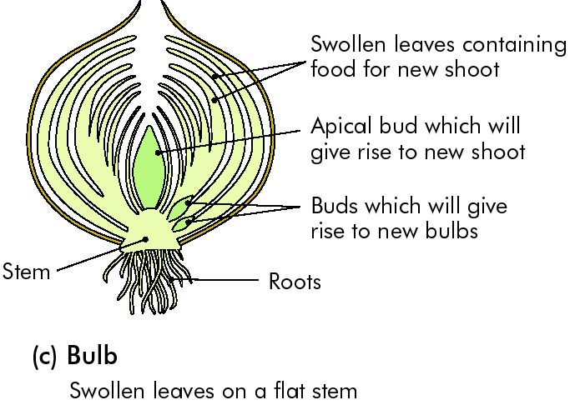
( c ) Modified leaves
Leaves can be modified for food storage e.g. onion bulbs
Sugar is the reserve food.

