At the end of this section you should be able to ….. | Y | N
Describe the root system and shoot systems of a flowering plant.
Describe the structures and function of each portion to include all the outer stem parts and root zonations.
Explain the term meristem.
Identify its location in the shoot and root apices.
Describe the function of the meristem
Know the 4 tissue types
Know the function of the 4 tissue types
Know the location of 3 tissue types in a T.S. of the root, stem and leaf
Know the function of the 3 tissue types in a L.S. of the root and stem.
Know the 2 vascular tissues in angiosperms.
Describe each of their functions of the vascular tissues.
Draw and identify each tissue type.
Practical Activity
Prepare and examine microscopically the T.S. of a dicot stem x100, x400

Key words
Fibrous, Tap, Node, Internode, Apical, Meristem, Differentiation, Lamina, Netted, Parallel, Dermal, Ground, Vascular, Xylem,Vessels, Tracheids, Phloem, Companion cell, Lignin, Monocotyledon, Dicotyledon

Flowering plant divided into a root system and a shoot system
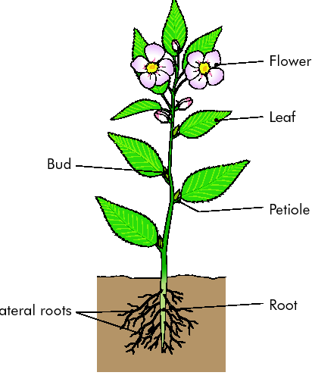
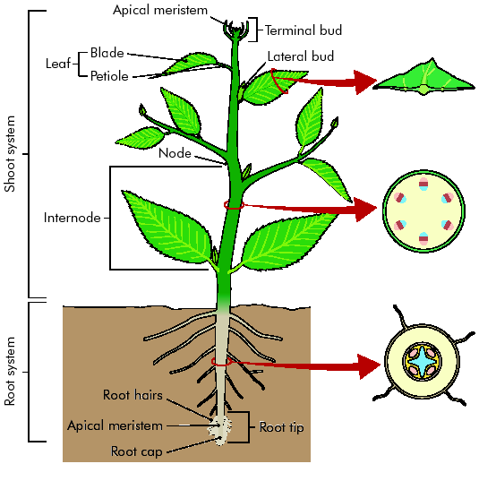

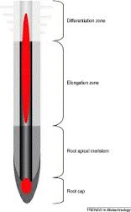
ROOT
Root Zonation
Zone of differentiation
Zone of elongation
Apical meristem
Root cap

Types of root systems:
- Tap
- Fibrous

Functions of the root
- Anchorage
- Absorption
- Storage

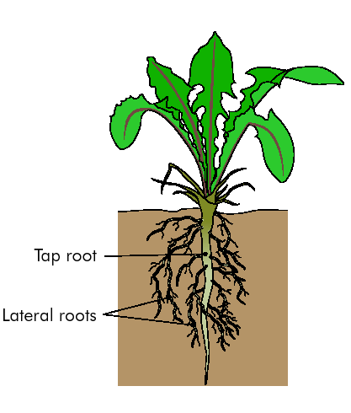
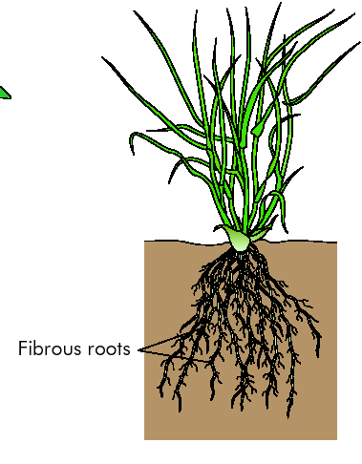

SHOOT: Stem, Buds, Leaves, Flowers
Stem:
Buds
- Apical - growth
- Lateral – side shoots and branches
- Node – Place where leaves attached to stem
- Internode – Space between nodes

- Supports aerial parts
- Transports water and minerals
- Transports food
Leaves:
- Lamina
- May be attached to stem by petiole or else not attached (sessile)
- Veins – netted or parallel

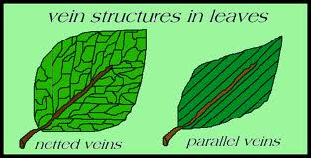

Functions of leaf
- Photosynthesis
- Gaseous exchange
- Transpiration

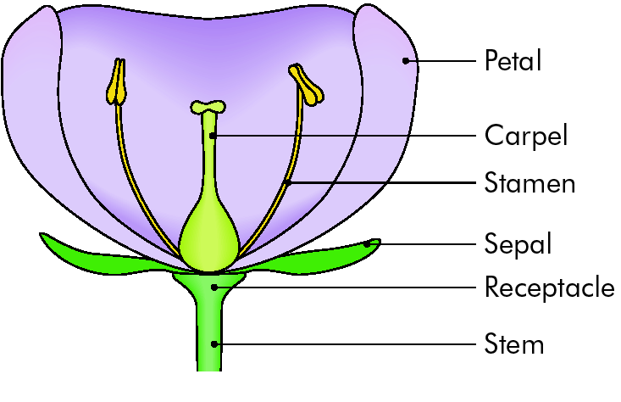
Flowers
- Sepals
- Petals
- Stamens
- Carpels

Function of flower:
Reproduction

Meristem.
- Region in which cells are continuously dividing

Location of meristems in the shoot and root .
- Tip of shoot
- Tip of root

Meristematic tissue divides to produce new cells. These cells differentiate (specialise) to produce 3 types of tissue:
- Dermal tissue – forms the protective covering of plants
- Ground tissue – fills the interior
- Vascular (transport) tissue – conducts water and nutrients in a plant.

Location of 3 tissue types in the L.S. and T.S. of a root and stem and T.S. of a leaf
- L.S. and T.S. of the root,

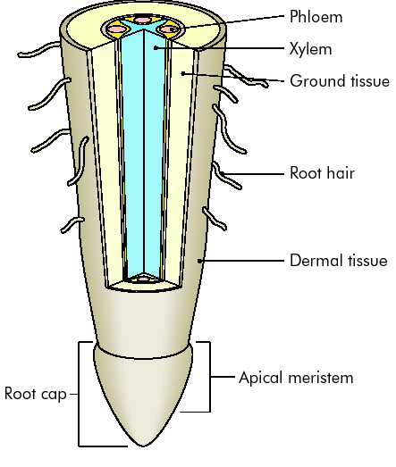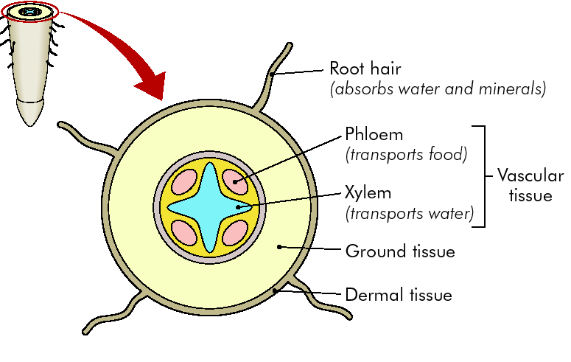
L.S. of Root
T.S. of Root

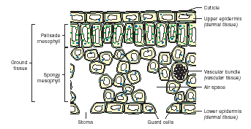
T.S. Leaf

L.S. and T.S. of the stem
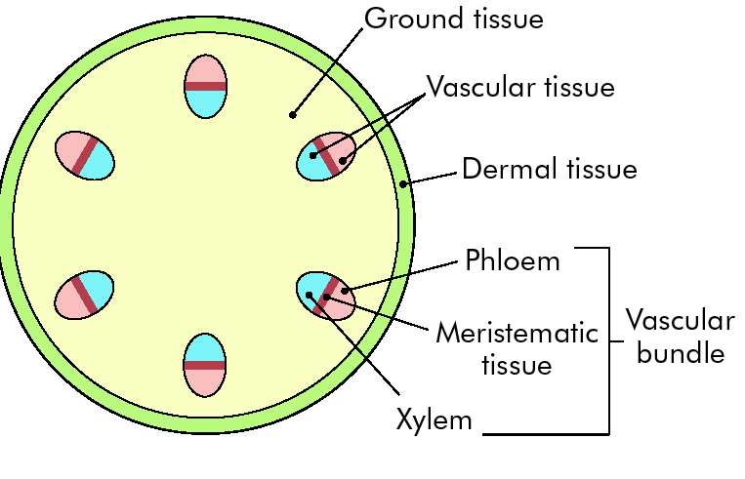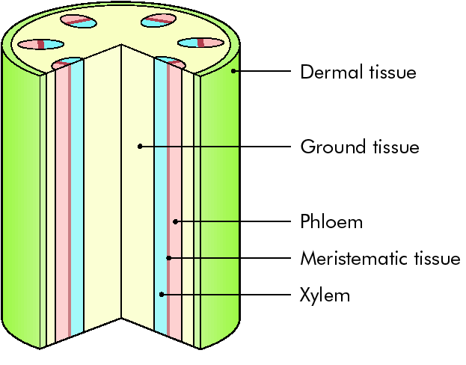
T.S. of Stem
L.S. of Stem

Vascular tissue
- Xylem
- Phloem

Xylem
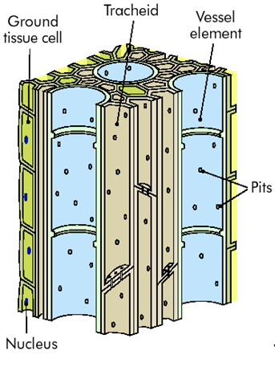
Xylem: Transport of water up the plant

Xylem tissue consists of tracheids and vessels

Tracheids and vessels are dead and hollow at maturity i.e. have no cytoplasm

Tracheids are
- Long cells, tapered at both ends, with pits in the walls.
- Allows water and minerals move sideways from cell to cell.
- Thickened with lignin for support.

Vessels:
- Elongated cells with walls thickened in spiral bands.
- Lack end walls and when mature form a continuous conducting pipe.
- Wider than tracheids and when stacked together are known as xylem vessels.
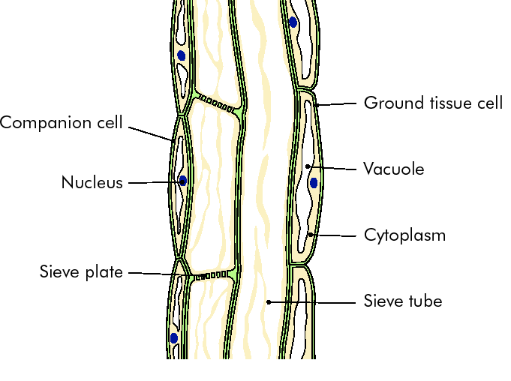

Phloem
Phloem: Transport of food around the plant

Consists of Phloem sieve tubes and companion cells

Sieve tube cells
- Are elongated cylindrical cells stacked end to end.
- End walls have holes - sieve plates
- Allow cytoplasm to move from one sieve tube cell to another..
- When mature the nucleus disintegrates.
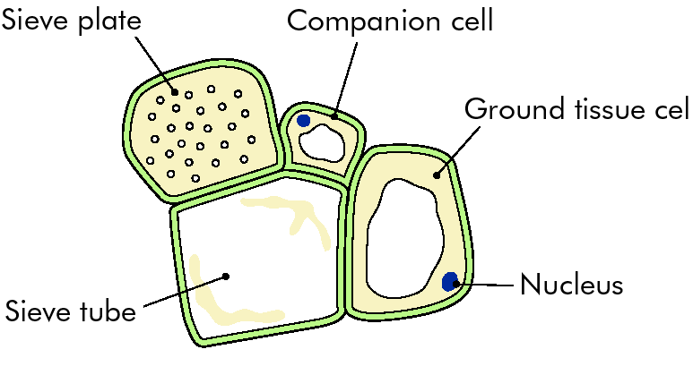
- Companion cell beside it has a nucleus
- This controls the activities of itself and sieve tube cell
- It is connected to tube cell by cytoplasmic extensions

Monocotyledons and Dicotyledons

Monocotyledons: 1 seed leaf
Dicotyledons: 2 seed leaves

 | Monocotyledons | Dicotyledons
Number of cotyledons | One | Two
Arrangement of vascular bundles in the stem | Scattered | Ring pattern
Leaf venation | Parallel | Netted
Number of flower parts | In threes | In fours and fives
Woody/ Herbaceous | Almost all herbaceous | Woody or herbaceous

Prepare and examine microscopically the transverse section of a dicotyledenous stem (x100, x400)
Procedure
- Cut a short length of wet stem ( e.g. geranium) using the blade. Cut at the node, at right angles to the stem, away from the body, to get a very thin transverse section.
- Repeat several times, placing each transverse section in the petri dish of water.
- With the paintbrush, remove the thinnest sections from the water and place them on a microscope slide in a drop of water. Blot off excess water.
- Add a coverslip and label the slide.
- Examine under the microscope.
- Draw labelled diagrams of what is seen.

