Qualitative test for A REDUCING SUGAR e.g. glucose

CHEMICALS

Glucose solution

Benedict’s reagent

Water
PROCEDURE

- I placed glucose solution into tube A.
- I placed water into tube B. This acted as a control.
- I added Benedict’s reagent to each tube.
- I placed both tubes in the hot water bath and heated for 5 minutes.
- I recorded my result.

RESULT

Sample | Initial colour | Final colour
A – Glucose solution | Blue | Brick red
B - Water | Blue | Blue

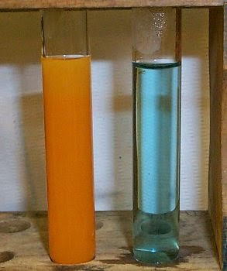
Test for reducing sugar
Glucose + Benedicts = Brick red

