Qualitative test for PROTEIN
DIAGRAM
CHEMICALS

Protein solution e.g. milk
Biuret reagent
Water

PROCEDURE

- I placed the milk into tube A.
- I placed water into tube B. This acted as a control.
- I added Biuret reagent to each tube
- I recorded my results.

RESULT

Sample | Initial colour | Final colour
A – Protein solution | Blue | Lilac
B - Water | Blue | Blue

RESULT

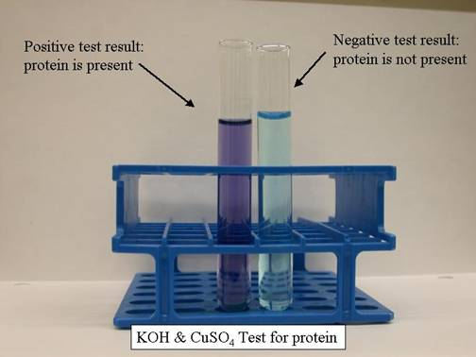

Test for Protein
Protein + Biuret = Lilac

