At the end of this section you should be able to …
Understand the sense organs contain receptors.
Explain how the brain acts as the interpreting centre for received information.
Describe the 5 senses and related organs.
Recognise the main parts of the eye
Recognise the main parts of the ear.
Give a single statement of function related to each part.
Describe the corrective measures for long sightedness and short sightedness or for a hearing defect.
The Senses - Summary

Organ | Skin | Tongue | Nose | Eye | Ear
Sense (Stimulus) | Touch  Temperature | Taste | Smell | Sight | Hearing

Each sense organ contains sensory receptors which detect stimuli. A stimulus is a change in the internal or external environment. These receptors send messages to the brain via sensory nerves which acts as an interpreting centre.

Examples

The skin contains receptors which react to stimuli e.g. heat, pressure, pain.
Message is sent to brain along sensory nerves
Brain interprets the message as pain etc

The tongue contains receptors which react to chemical stimuli.
Message is sent to brain along sensory nerves
Brain interprets the message as taste

The nose contains receptors which react to chemical stimuli
Message is sent to brain along sensory nerves
Brain interprets the message as smell

The eye contains receptors which react to the stimulus of light
Message is sent to brain along sensory nerves
Brain interprets the message as sight

The ear contains receptors which react to the stimulus of sound
Message is sent to brain along sensory nerves
Brain interprets the message as hearing

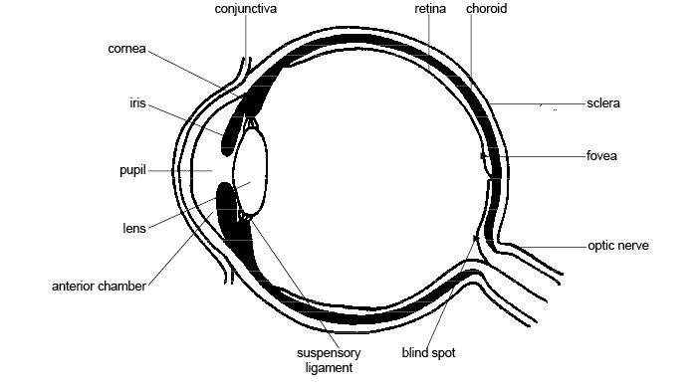
The Eye

Part | Function
Sclera | Tough outer coat for protection (White)
Cornea | Transparent layer at front of eye. Allows light through
Choroid | Black layer. Absorbs light. Prevents internal reflection
Ciliary body | Contains ciliary muscle to focus the lens
Iris | Controls the amount of light entering the eye (Coloured)
Aqueous humour | Helps maintain the shape of the eye  Bends light
Vitreous humour | Helps maintain the shape of the eye  Bends light
Retina | Light sensitive area. Contains the light receptors – rods and cones
Rods | Light sensitive receptors which responds to black and white
Cones | Light sensitive receptors which responds to colour

Short sight (Myopia)
Short sight leads to blurred distance vision, but close vision is normal (- values on a prescription)
Long sight (Hypermetropia)
Long sight leads to blurred close vision, but distant vision is normal (+ values on a prescription)

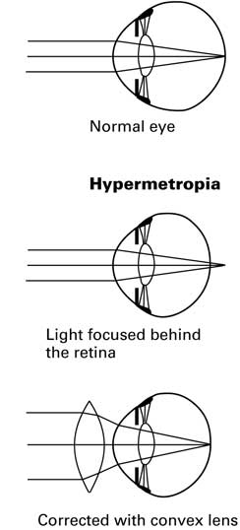
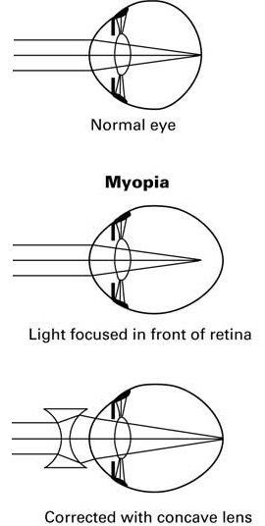

Normal vision: Rays from the object are focused on the retina

If you have 20/20 vision, it means that when you stand 20 feet away from the chart you can read the chart clearly.

Binocular vision: The brain interprets information from two eyes simultaneously giving 3D image. This helps improve the perception of depth

The Ear
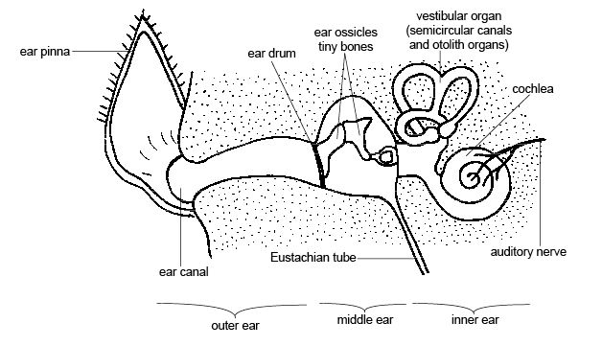
Hammer, anvil, stirrup

Part | Function
Pinna | Funnels sound waves into ear canal
Ear canal | Carries sound waves to ear drum
Ear drum | Receives sound waves. Vibrates
Eustachian tube | Connects middle ear with the outside. Equalises pressure
Hammer | Picks up vibrations from the ear drum. Passes vibrations to anvil
Anvil | Picks up vibrations from the hammer. Passes vibrations to stirrup
Stirrup | Picks up vibrations from anvil. Passes the vibrations through the oval window into the cochlea.
Oval window | Amplifies sound waves and passes them to the cochlea
Cochlea | Coiled fluid filled structure. Contains tiny hair receptors which convert the vibrations into a nerve message.
Auditory nerve | Carries the nerve message to the brain where it is interpreted as sound.
Round window | Vibrations pass back through round window
Semi circular canals | Fluid filled structures containing receptors. Responsible for balance.

